**ADB**

* ADB is a Android debug bridge
* It is a command line tool which communicates with android device
* it helps you in installing and debugging apps
* Access to unix shell(it allows to run different commands on android)

**Setup before start the ADB**

* First install the ADB zip file and extract it
* <<https://developer.android.com/studio/releases/platform-tools>path of adb here>
* Start the command line from same folder where you installed ADB binary
* From settings->About phone on your device, click on build ID for seven times and this will enable developer options on phone
* Now enable the USB debugger in developer option
* Final step is to connect the device with pc

**Components of ADB**

* **Client:** Sends commands to android
* **Daemon:** It run as background process in android. Daemon is used to executes the commands whatever client sends
* **Server:** Server is running as background process in pc and manages the commands b/w clients and Daemon

**ADB Commands**

1. **adb devices**

To check if any device is connected to your system

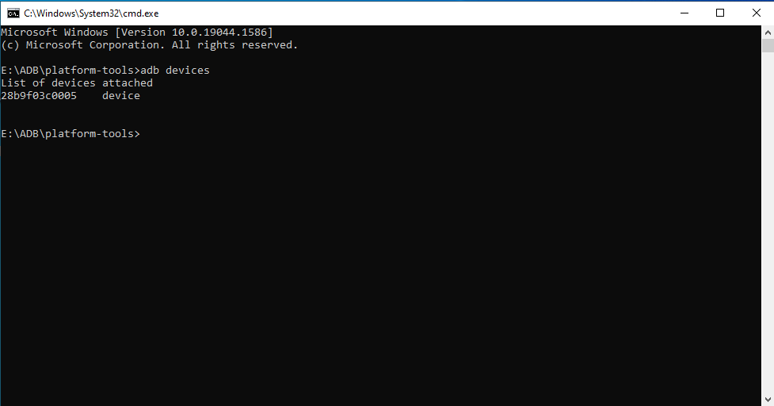

**Fig 1: adb devices**

1. **adb kill -server**
2. **adb start –server**

use this commands if your device is not showing after adb devices

1. **adb shell & then give ls**

It will list all the folders in your android

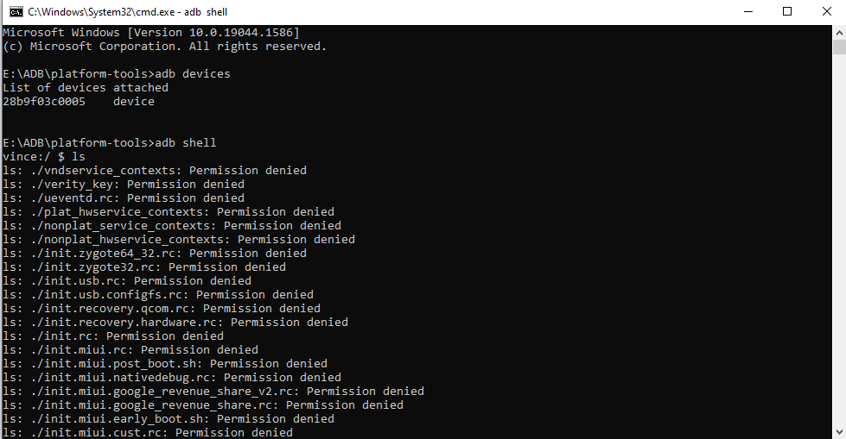

**Fig 2: adb shell**

1. **adb push “source.jpg” /sdcard/data/temp**

To push file from PC to android

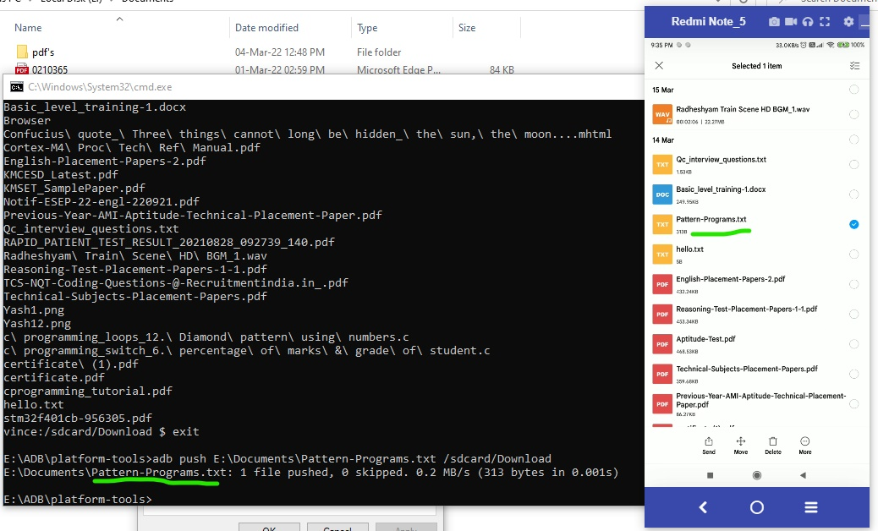

**Fig 3: adb push**

1. **adb pull /sdcard/abc.txt user/admin/desktop**

**(source location) (destination location)**

To pull any file from device(android) to PC

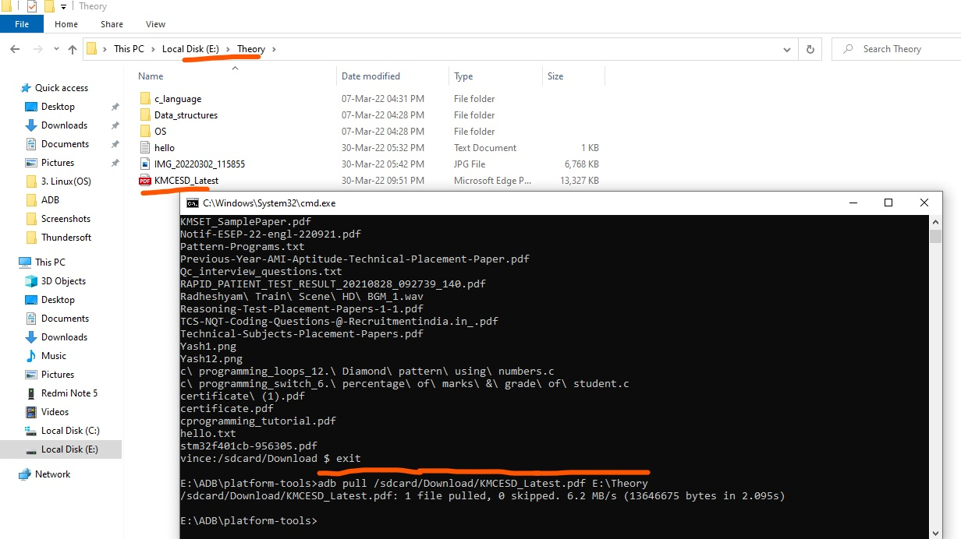

**Fig 4: adb pull**

1. **adb shell pm list packages**

To find the packages present on the device

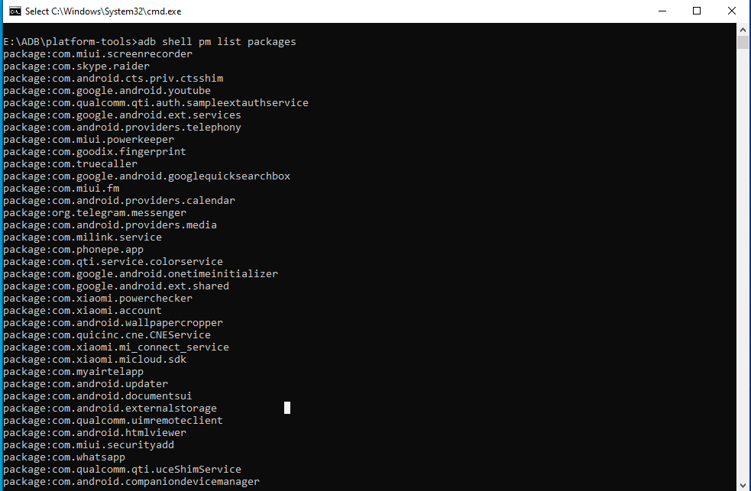

**Fig 5: adb shell pm list packages**

1. **adb reboot**

To Reboot your device

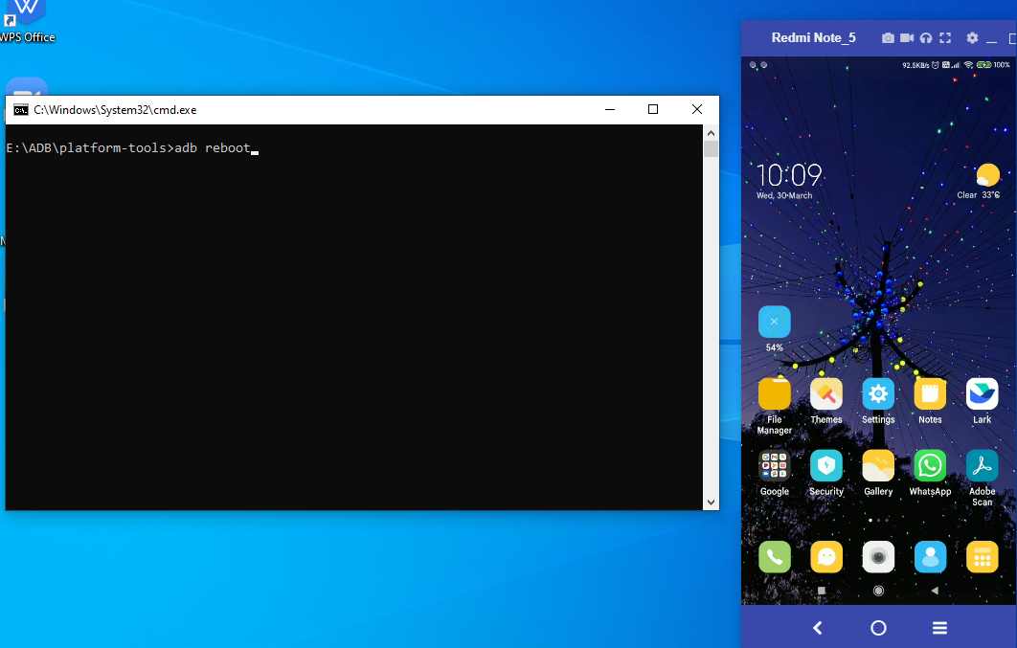

**Fig 6 a. adb reboot**

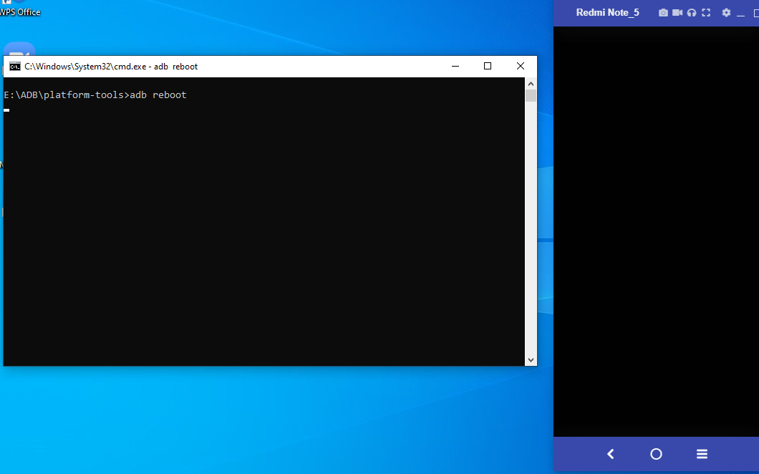

**Fig 6 b. adb reboot**

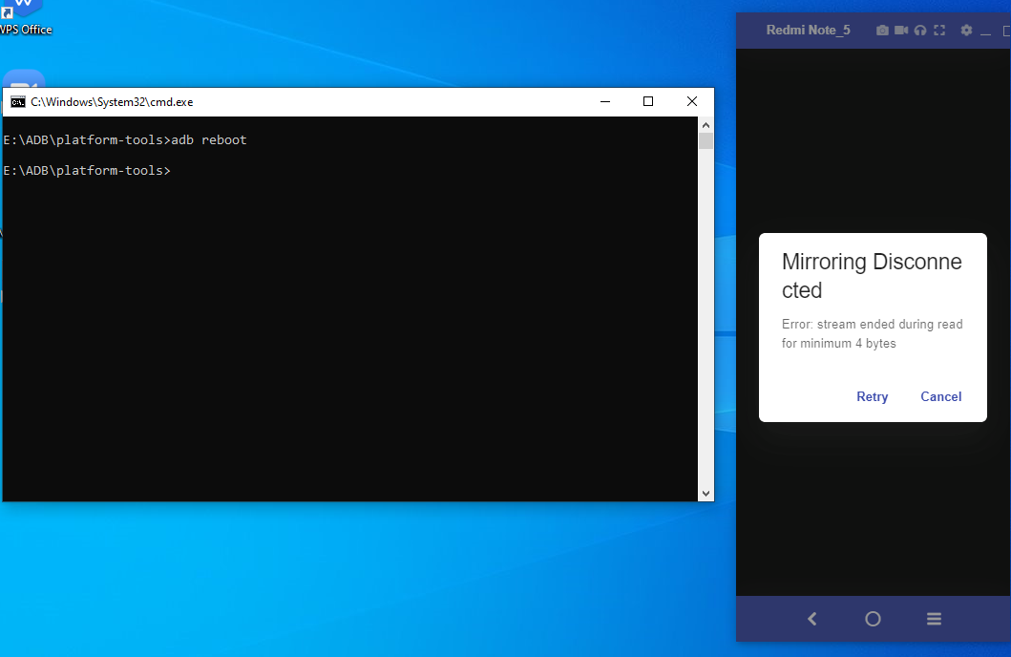

**Fig 6 c. adb reboot**

1. **adb shell settings put system screen_brightness 0**

To set or put the data in settings applications . For screen brightness

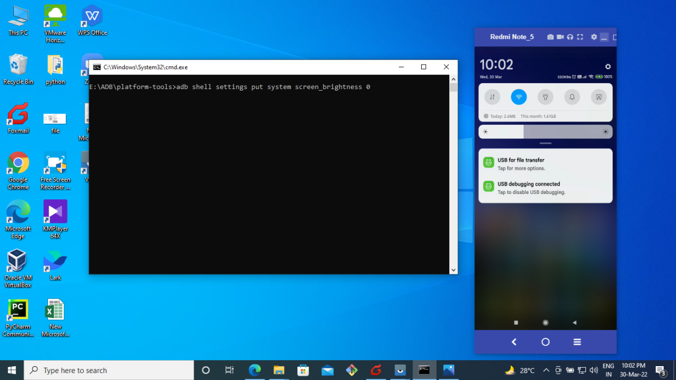

**Fig 7 a: Brightness before executing 0**

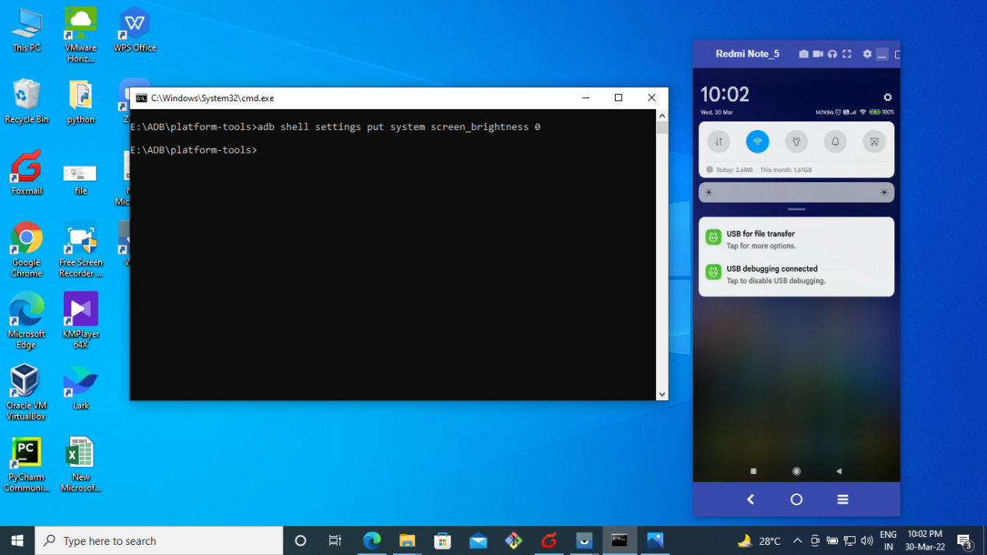

**Fig 7 b: Brightness after executing 0**

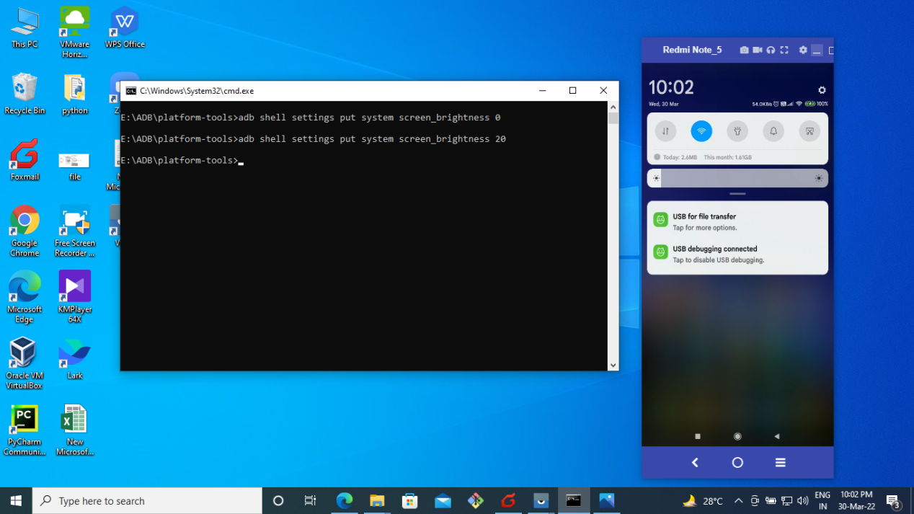

**Fig 7 c. Brightness after executing 20**

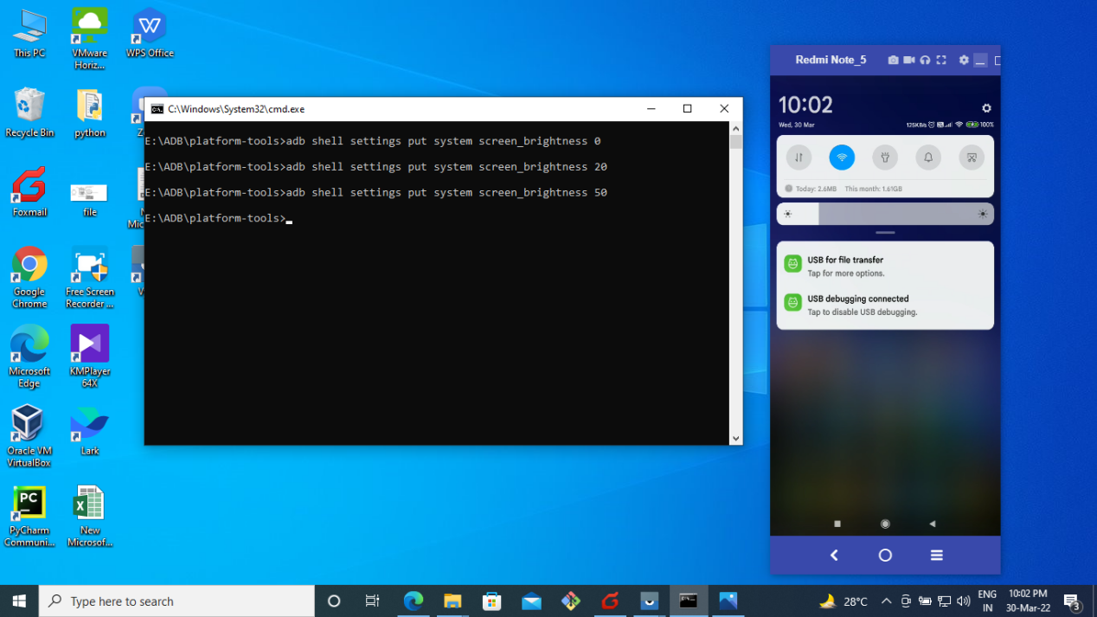

**Fig 7 d. Brightness after executing 50**

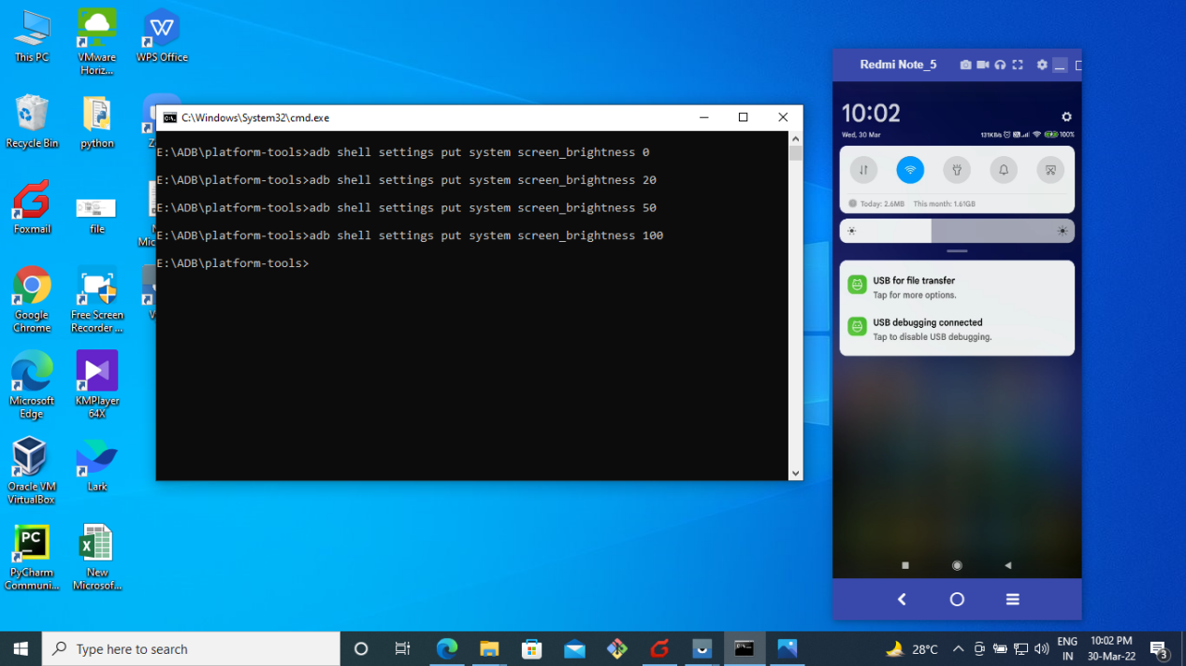

**Fig 7 d. Brightness after executing 100**

1. **adb shell settings get system screen_brightness**

To get the data in settings applications. For screen brightness

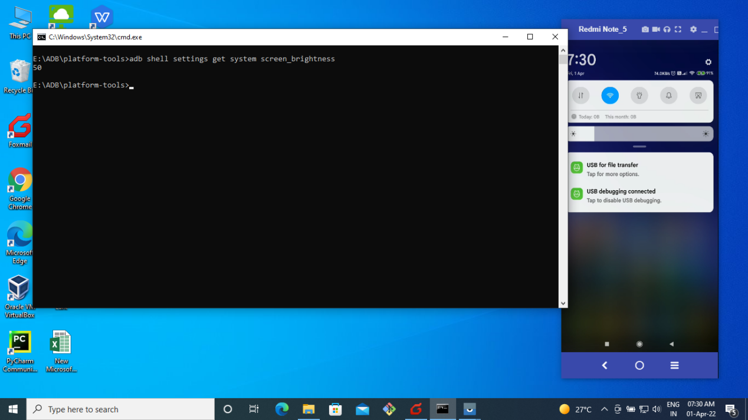

**Fig 8 a. Get brightness from android**

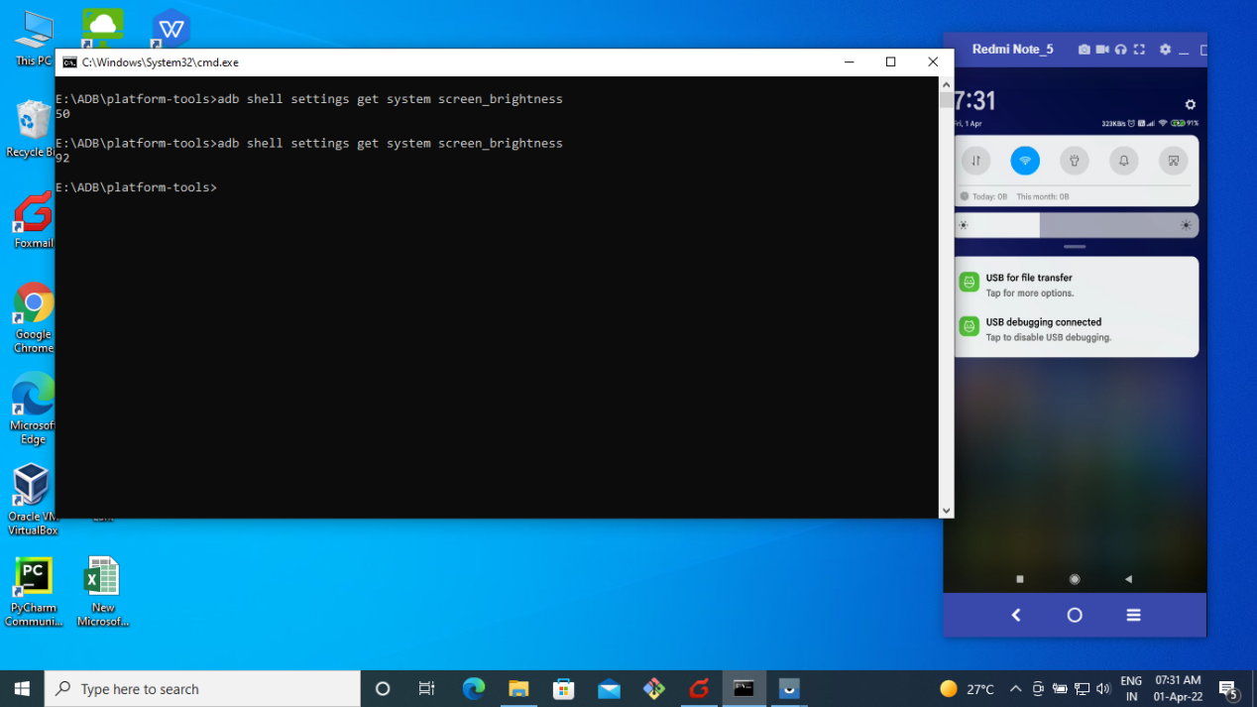

**Fig 8 b. Get brightness from android**

**11. adb shell screencap -p /sdcard/screencap.png**

**(destination location)**

To screen capture

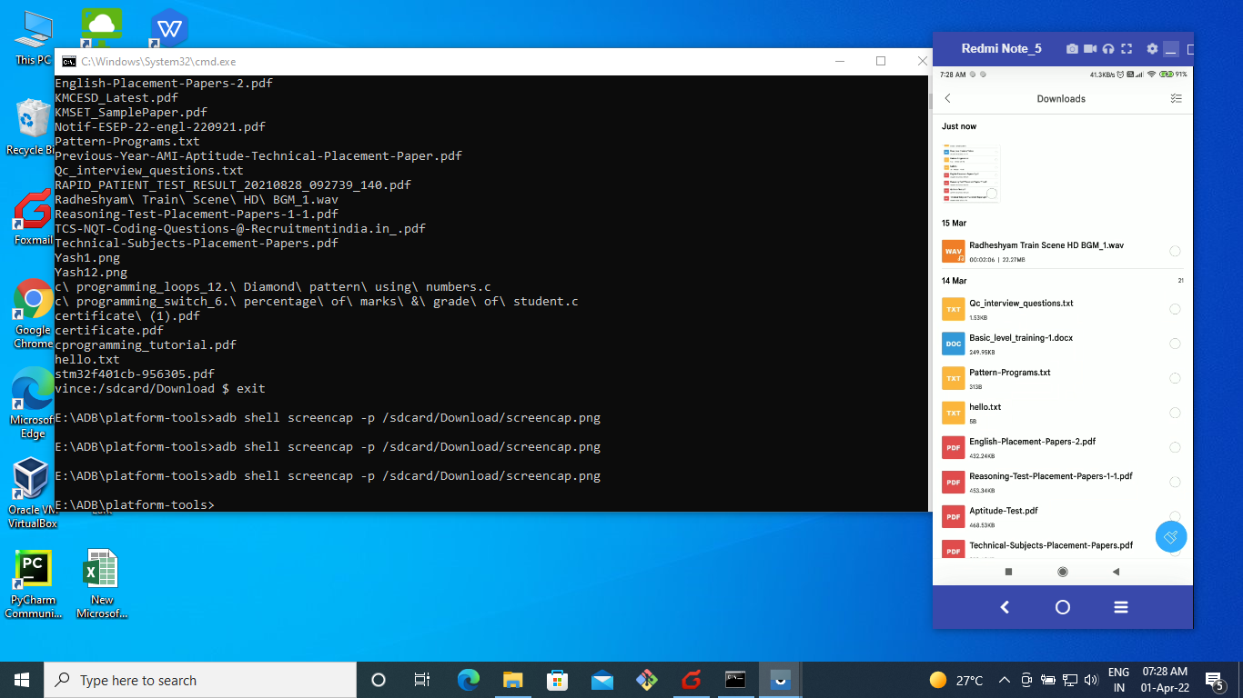

**Fig 9. To capture the screen**

1. **adb shell ps**

to see processes in the android

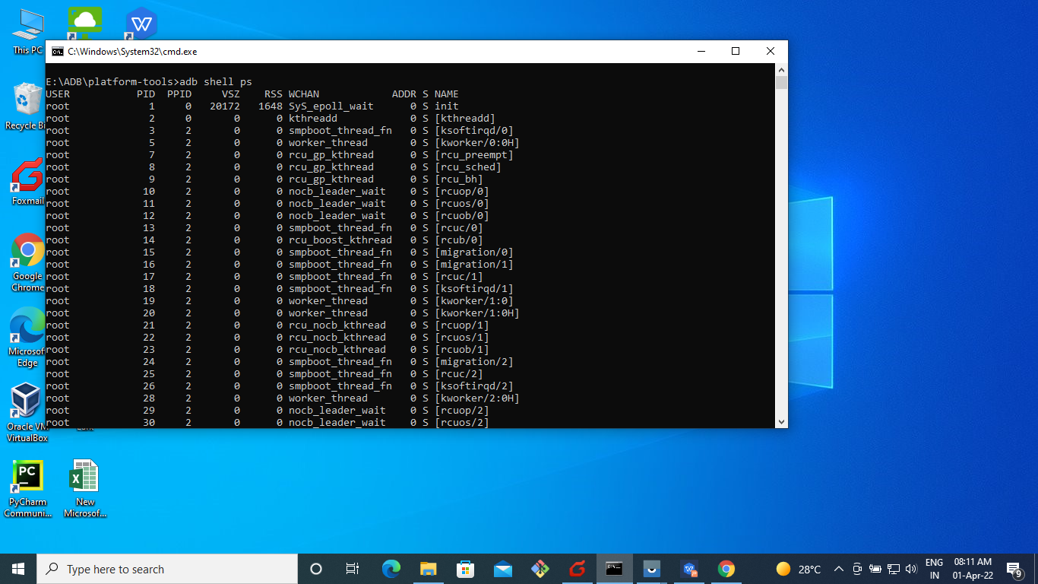

**Fig 10. to see processes in the android**

1. **adb shell input text “\typing\on\adb\is\ cool”**

To give the input text

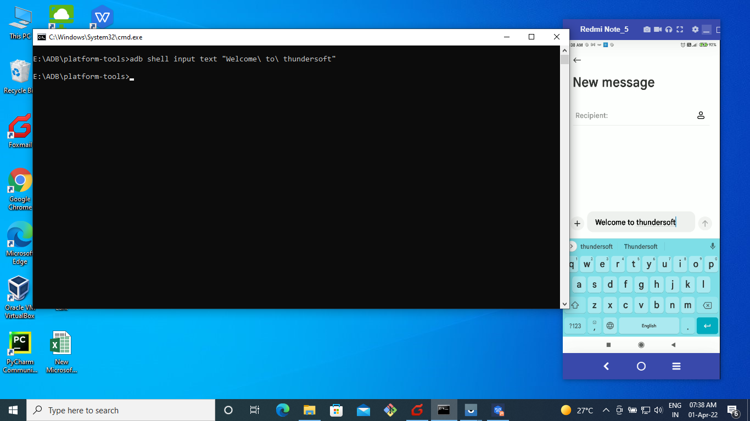

**Fig 11. To give the input text**

1. **adb shell pm list packages |findstr packagename**

It will shows particular package name

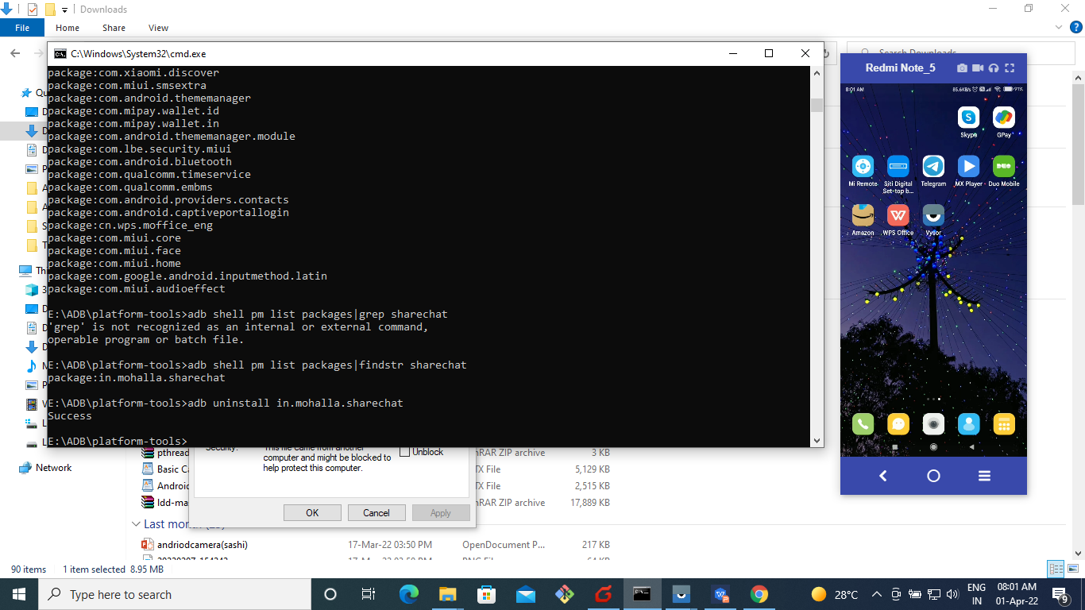

**Fig 12. It will shows particular package name**

1. **adb tcpip 5555**
2. **adb connect 192.168.2.001**

**(ip address)**

To connect the device over wifi

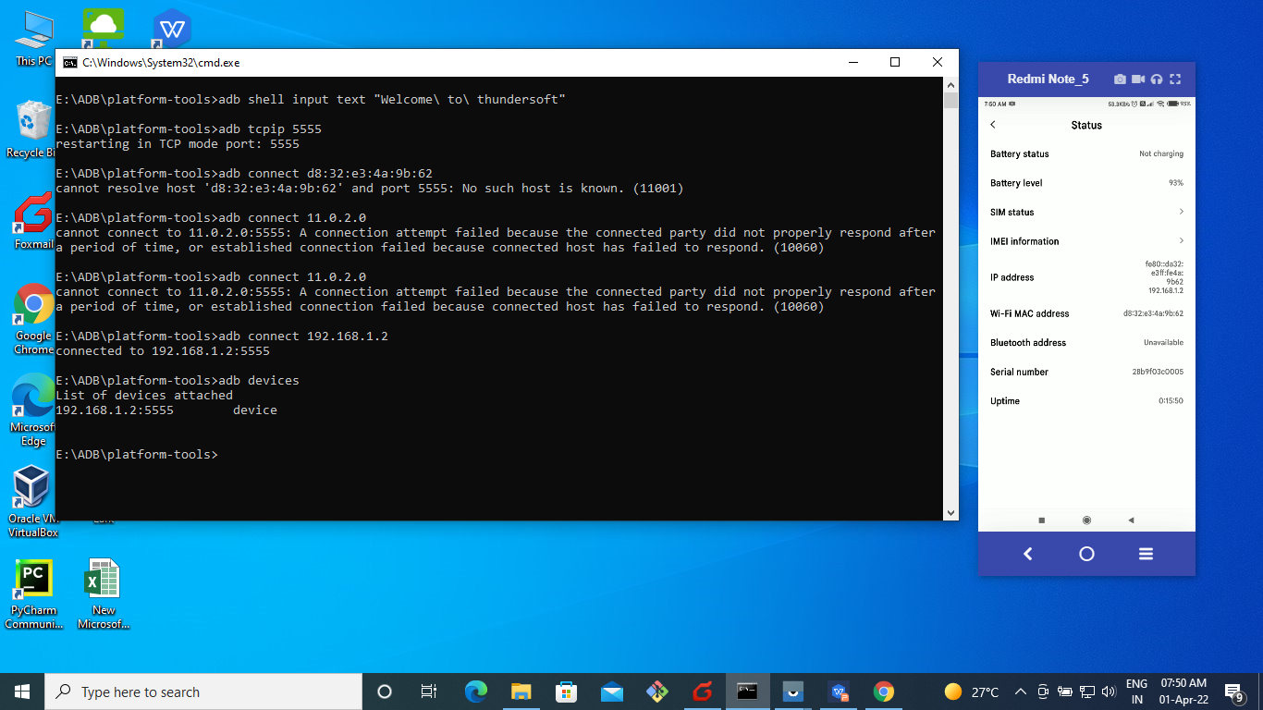

**Fig 13. To connect the device over wifi**

1. **Adb shell cat /sdcard/Download/file.txt**

**(Android path location)**

It will display content in the file

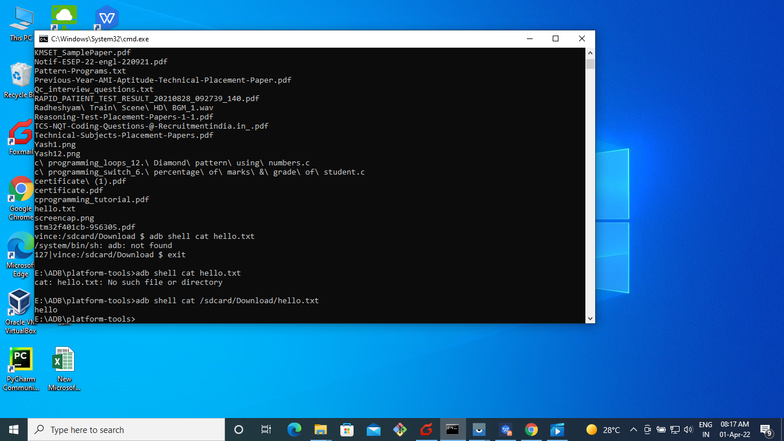

**Fig 14. a. It will display content in the file**

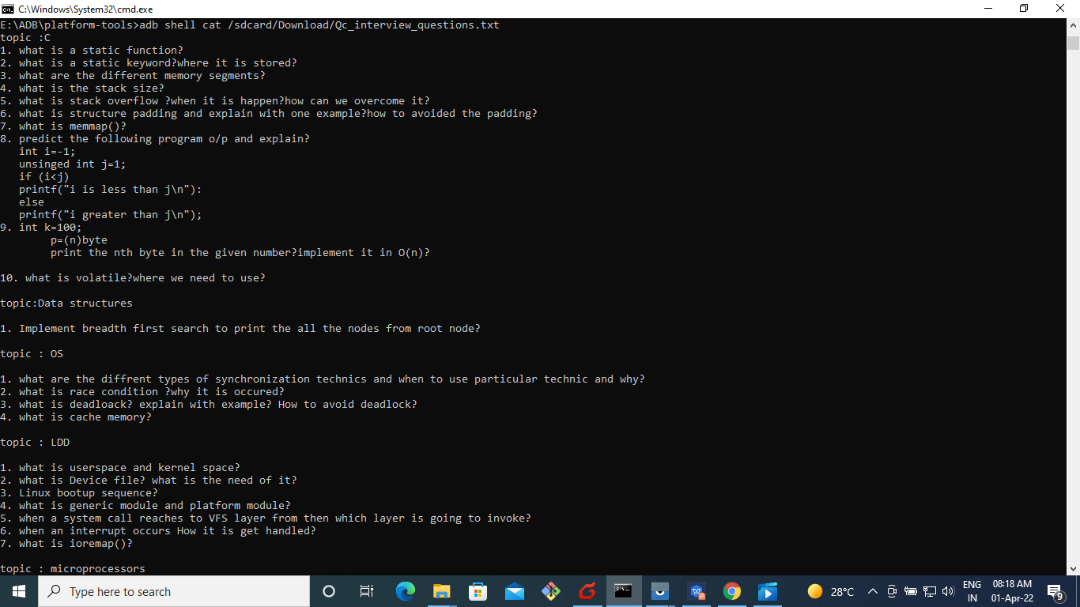

**Fig 14. b. It will display content in the file**

1. **adb uninstall “package name”**

To uninstall an application on android

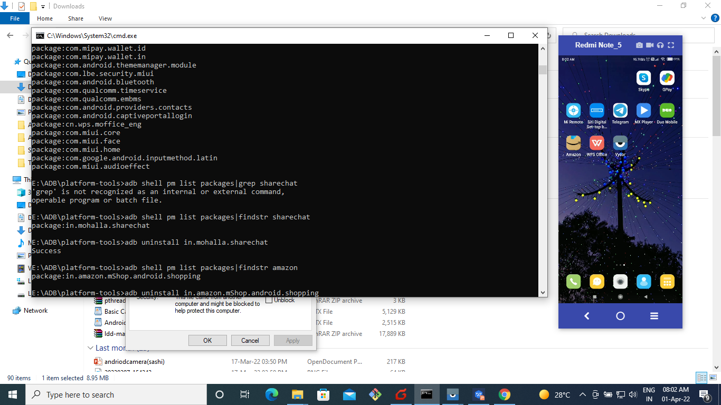

**Fig 15. a. To uninstall an application on android**

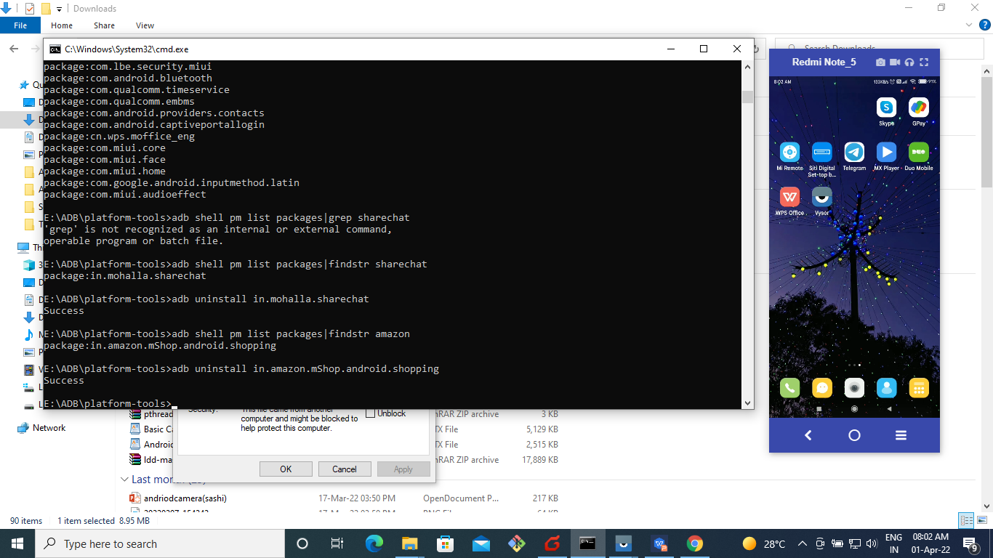

**Fig 15. b. To uninstall an application on android**